**Communication Point**

Twitter: [**@EColorRace**](https://twitter.com/EColorRace)

**Monday**

1. https://twitter.com/EColorRace/status/696720505097814016

“Welcome to the EColorRace project! If you want to know more about E.coli and fluo, let's follow our twitter account! [#**BiosensorsFDV**](https://twitter.com/hashtag/BiosensorsFDV?src=hash) [#**Ecoli**](https://twitter.com/hashtag/Ecoli?src=hash)”

**2)** <https://twitter.com/EColorRace/status/696739514048454656?lang=fr>

“Here the team: Floriane, Régine, Lucile and Cécile! [#**BiosensorsFDV**](https://twitter.com/hashtag/BiosensorsFDV?src=hash) [#**EColorRace**](https://twitter.com/hashtag/EColorRace?src=hash) [#**scientificproject**](https://twitter.com/hashtag/scientificproject?src=hash) [#**science**](https://twitter.com/hashtag/science?src=hash) “

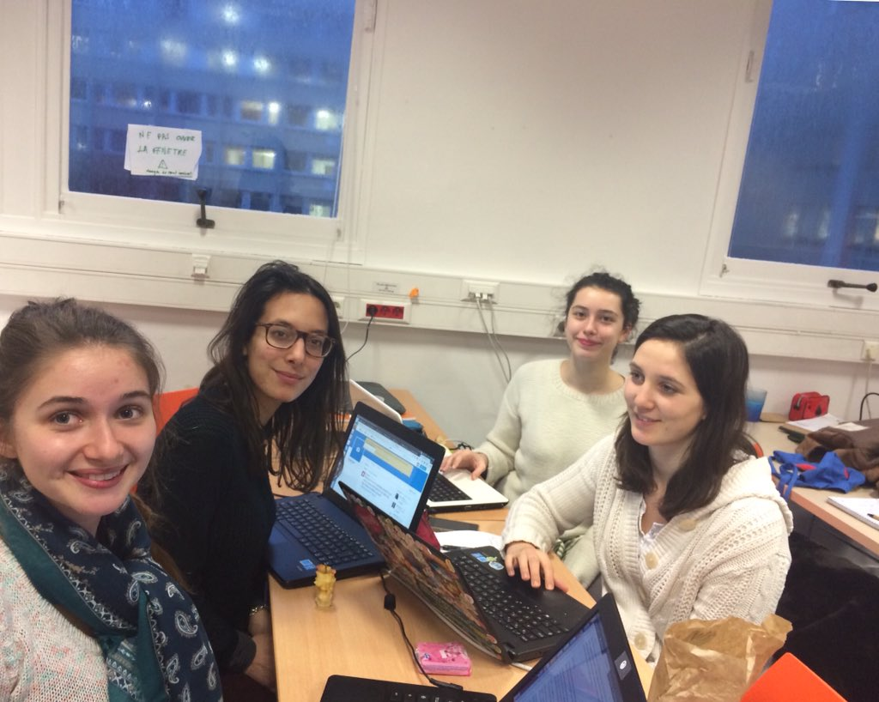

**3)**  https://twitter.com/EColorRace/status/696744573490610178

“Does an hungry group of E.coli move faster than a not hungry one to a concentration of nutriment? [#**BiosensorsFDV**](https://twitter.com/hashtag/BiosensorsFDV?src=hash) [#**Bacteria**](https://twitter.com/hashtag/Bacteria?src=hash) [#**Ecoli**](https://twitter.com/hashtag/Ecoli?src=hash)”

**4)** <https://twitter.com/EColorRace/status/696798420686733312?lang=fr>

“Find some more infos about mobility and growth of bacteria on this article: [https://www.weizmann.ac.il/mcb/UriAlon/sites/mcb.UriAlon/files/1-s2.0-s0022283612007401-main_0.pdf …](https://t.co/NzG4QNiGuS)

[#**BiosensorsFDV**](https://twitter.com/hashtag/BiosensorsFDV?src=hash) [#**JMB**](https://twitter.com/hashtag/JMB?src=hash) [#**journal**](https://twitter.com/hashtag/journal?src=hash) [#**science**“](https://twitter.com/hashtag/science?src=hash)

**5)** <https://twitter.com/EColorRace?lang=fr>

“First preparetion of the media for the E.coli. [#**BiosensorsFDV**](https://twitter.com/hashtag/BiosensorsFDV?src=hash) [#**Ecoli**](https://twitter.com/hashtag/Ecoli?src=hash) [#**lab**](https://twitter.com/hashtag/lab?src=hash)”

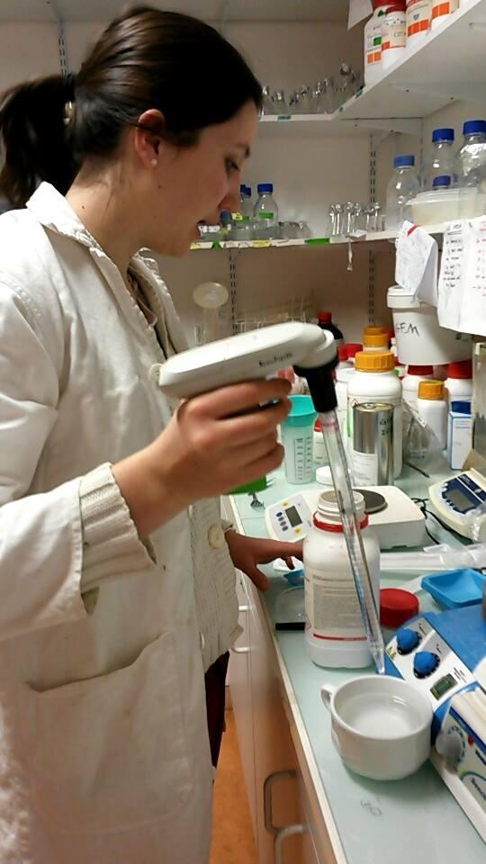

**Tuesday**

1. https://twitter.com/EColorRace/status/697001400170057728?lang=fr

“New day, new protocol! We decided to change a bit our protocol in order to not compromise our results. [#BiosensorsFDV](https://twitter.com/hashtag/BiosensorsFDV?src=hash)”

**2)** https://twitter.com/EColorRace/status/697156866376384512?lang=fr

“You can learn something more about our project with the following scheme of the protocol: [#BiosensorsFDV](https://twitter.com/hashtag/BiosensorsFDV?src=hash)”

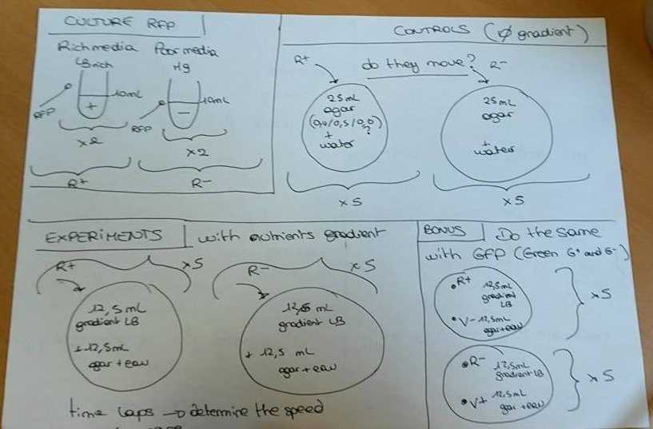

**3)** https://twitter.com/EColorRace/status/697158170779713536?lang=fr

“Trying new methods to have a diffusion of LB on a plate [#**BiosensorsFDV**](https://twitter.com/hashtag/BiosensorsFDV?src=hash) [#**Protocol**](https://twitter.com/hashtag/Protocol?src=hash) [#**lab**](https://twitter.com/hashtag/lab?src=hash) “

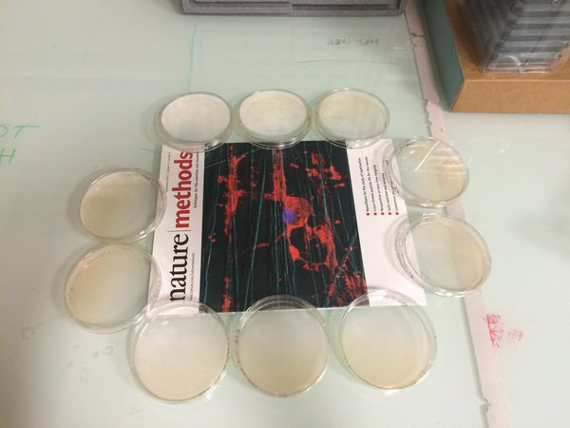 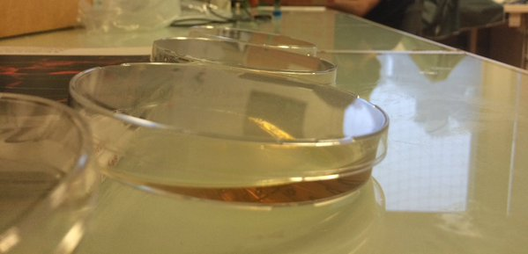

**4)** https://twitter.com/EColorRace?lang=fr

**“**Working in a sterilized environment! [#BiosensorsFDV](https://twitter.com/hashtag/BiosensorsFDV?src=hash) [#lab](https://twitter.com/hashtag/lab?src=hash) [#protocol](https://twitter.com/hashtag/protocol?src=hash)”

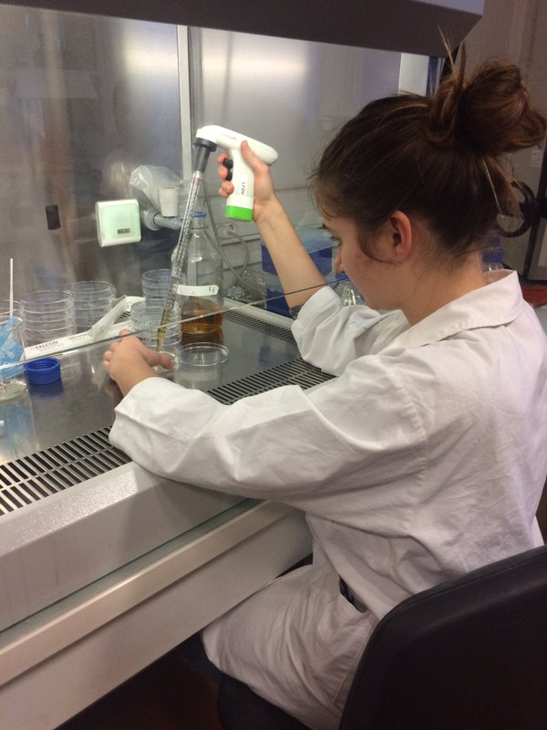

**5)** https://twitter.com/EColorRace/status/697160386525732864?lang=fr

“Let's give a look to this interesting article of Daniel B. Kearns on the mobility of flagella: [http://www.ncbi.nlm.nih.gov/pmc/articles/PMC3135019/ …](https://t.co/tNMDMHgi4T)

[#BiosensorsFDV](https://twitter.com/hashtag/BiosensorsFDV?src=hash)”

**Wednesday**

1. https://twitter.com/EColorRace?lang=fr

“Lab session unit night create mistakes: We put E.coli in solid LB instead to put it in liquid one!  [#**BiosensorsFDV**”](https://twitter.com/hashtag/BiosensorsFDV?src=hash)

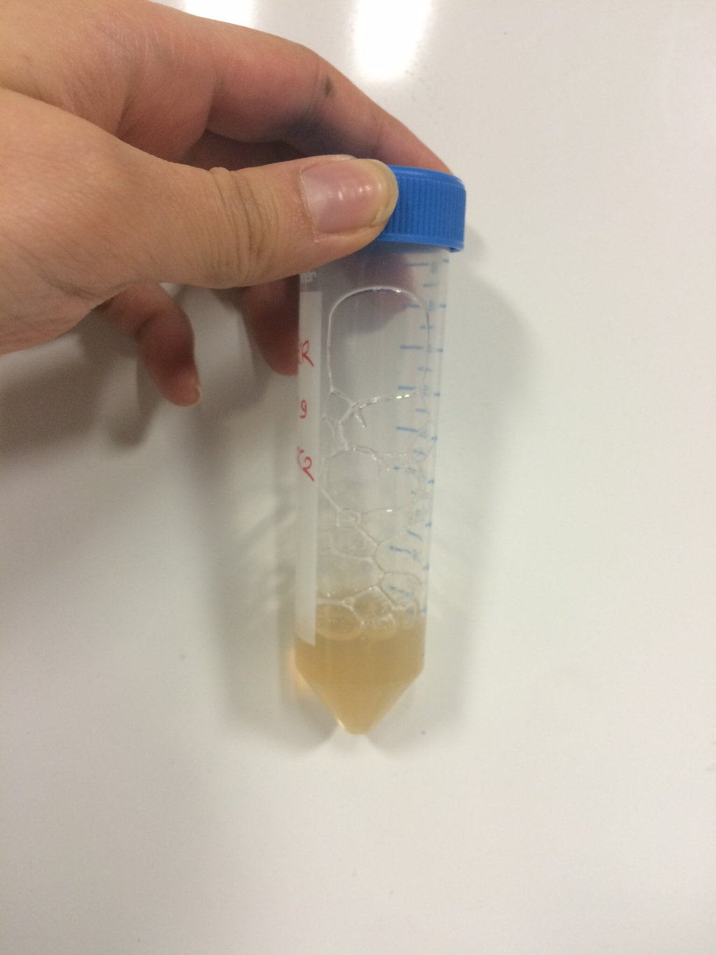

**2)** <https://twitter.com/EColorRace/status/697384576465895424?lang=fr>

“Are you wondering if we are only working on biology? No guys, we are also engineers! [#**BiosensorsFDV**](https://twitter.com/hashtag/BiosensorsFDV?src=hash) [#**engineering**](https://twitter.com/hashtag/engineering?src=hash)”

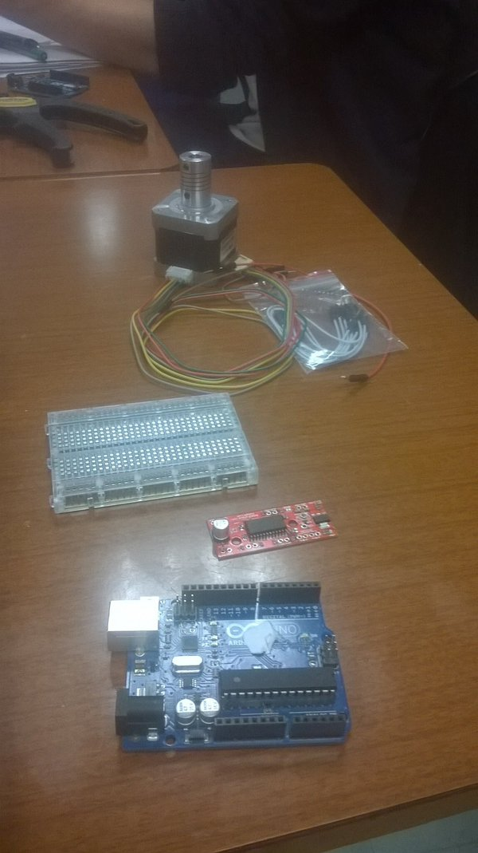

**3)** <https://twitter.com/EColorRace/status/697448308881682432?lang=fr>

“Our international student Paul Henry is helping us counting bacteria [#**BiosensorsFDV**](https://twitter.com/hashtag/BiosensorsFDV?src=hash) [#**lab**](https://twitter.com/hashtag/lab?src=hash) “

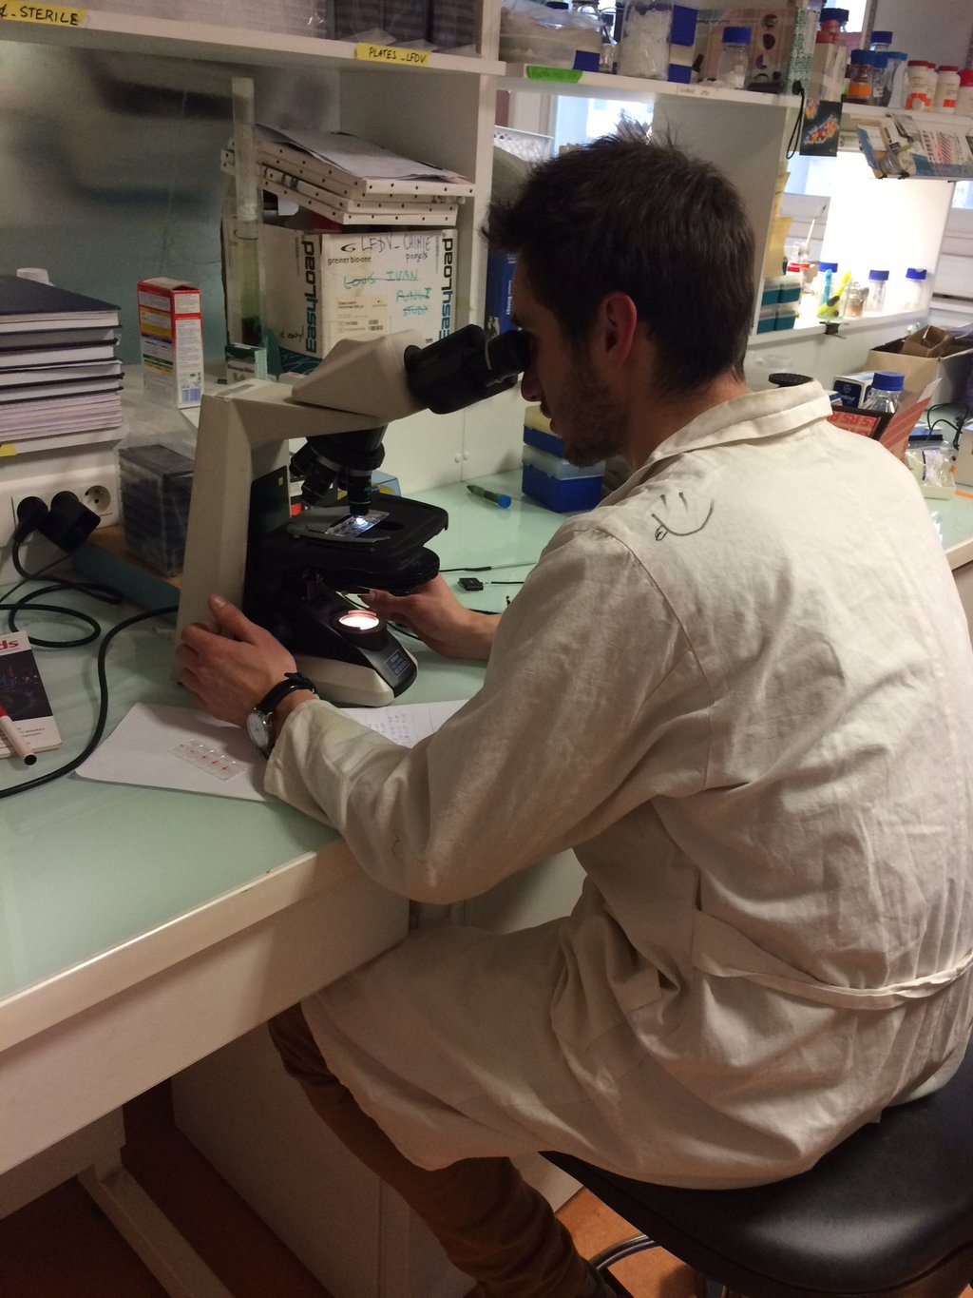

**4)** https://twitter.com/EColorRace/status/697549236825690116?lang=fr

“Do you remember the tweet about the engineering part of the project? Well, I was jocking! [#**BiosensorsFDV**](https://twitter.com/hashtag/BiosensorsFDV?src=hash) “

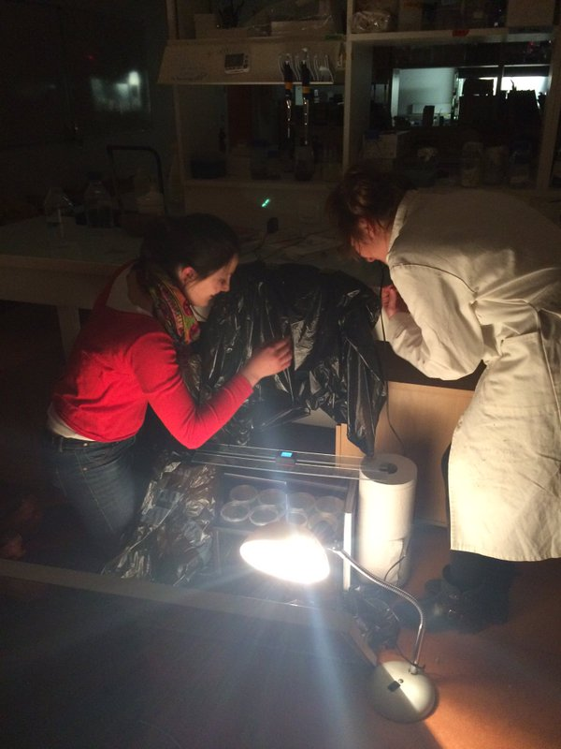

**Tuesday**

1. https://twitter.com/EColorRace/status/697724090686251008?lang=fr

“If you want to know more about bacteria, watch this nice video about their structure. [#BiosensorsFDV](https://twitter.com/hashtag/BiosensorsFDV?src=hash) [https://www.youtube.com/watch?v=fzIKJpcfXfo …](https://t.co/TwHv7vTrVE)”

**2)** https://twitter.com/EColorRace/status/697779478836211712?lang=fr

Here our E.coli with GFP under a uv lamp [#**biosensorsFDV**](https://twitter.com/hashtag/biosensorsFDV?src=hash)

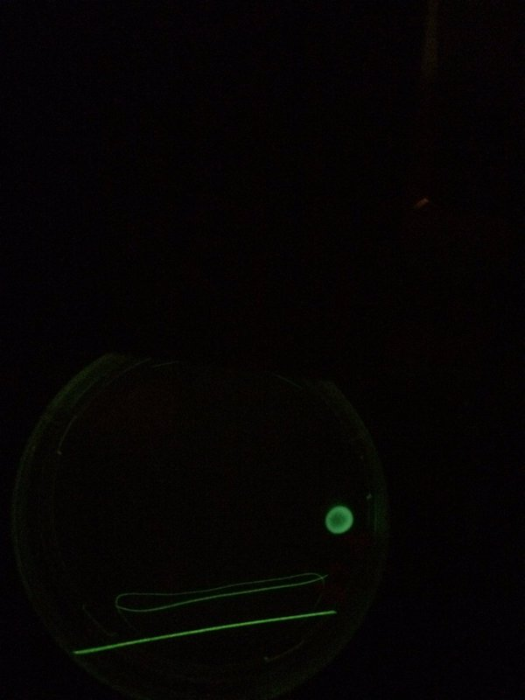

**3)** https://twitter.com/EColorRace/status/697808965766377473?lang=fr

Here a part of our motor for taking pictures! [#**BiosensorsFDV**](https://twitter.com/hashtag/BiosensorsFDV?src=hash)

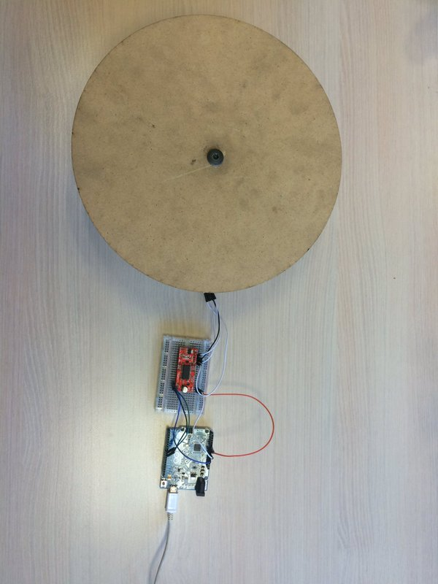

**4)**  https://twitter.com/EColorRace/status/697862984799023104?lang=fr

Graphs are getting ready [#**BiosensorsFDV**](https://twitter.com/hashtag/BiosensorsFDV?src=hash) [#**python**](https://twitter.com/hashtag/python?src=hash) [#**graph**](https://twitter.com/hashtag/graph?src=hash)

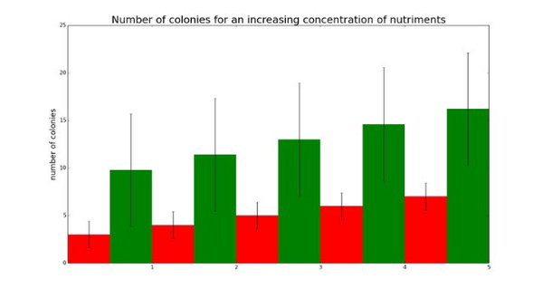

**Friday**

1. https://twitter.com/EColorRace/status/698078924962660352?lang=fr

“Today is the last day, we are still working hard! Don't lose the following infos regarding the presentation! [#**BiosensorsFDV**](https://twitter.com/hashtag/BiosensorsFDV?src=hash) [#**presentation**](https://twitter.com/hashtag/presentation?src=hash)”

**2)** <https://twitter.com/EColorRace/status/698138472645844992?lang=fr>

“We are ready!! Final presentation at 5pm! Let's give a look to our first slide! [#**BiosensorsFDV”**](https://twitter.com/hashtag/BiosensorsFDV?src=hash)



**3)** <https://twitter.com/EColorRace/status/698142300568993793?lang=fr>

“Girls working on [#**python**](https://twitter.com/hashtag/python?src=hash) For the final graphs! [#**BiosensorsFDV”**](https://twitter.com/hashtag/BiosensorsFDV?src=hash)

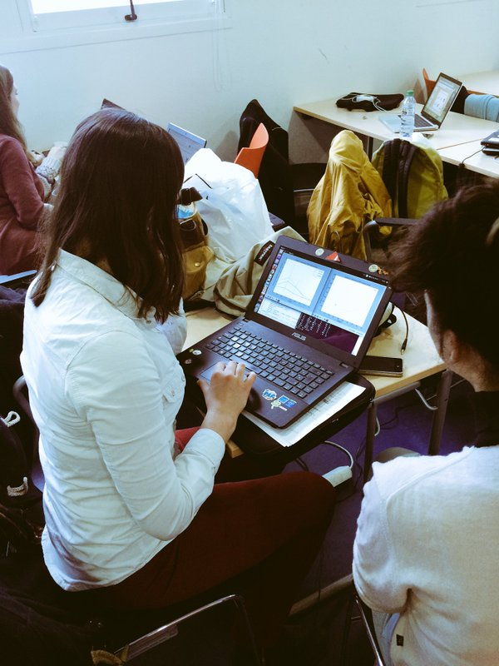

**4)** <https://twitter.com/EColorRace/status/698269995504177153?lang=fr>

“Biosensors are over! Such an amazing adventure! Thanks again to [@**aramataTM**](https://twitter.com/aramataTM) and all the biosensors' team for this crazy month![#**biosensorsFDV**](https://twitter.com/hashtag/biosensorsFDV?src=hash)”

**Monday**

1. <https://twitter.com/EColorRace/status/699234508319625220?lang=fr>

“Do you want to know more about our project? Here you can find our blog post with more informations [#**BiosensorsFDV**](https://twitter.com/hashtag/BiosensorsFDV?src=hash) [http://learningthruresearch.blogspot.fr/2016/02/does-escherichia-coli-respond-to.html …](https://t.co/h2IAYAdU0U)”

Mails:

Adresse mail: [regine.roncucci@cri-paris.org](mailto:regine.roncucci@cri-paris.org)

1. Mail sent to: [licencefdv2014@cri-paris.org](mailto:licencefdv2014@cri-paris.org),  **Tamara Milosevic** <[tamara.milosevic@gmail.com](mailto:tamara.milosevic@gmail.com)>, **Ivan Cornut** <[iv.cornut@gmail.com](mailto:iv.cornut@gmail.com)>, **El Assimi Aïmen** <[aimen_el@hotmail.com](mailto:aimen_el@hotmail.com)>, **Dusan Misevic** <dule@alife.org>

“Hello everyone,

Me and my team, Cécile, Floriane and Lucile, we will be at the OPEN LAB tomorrow morning and we will use the LAB in Cochin the rest of the week.

Have a good week!

The EColorRace team”

**2)** Mail sent to: **Uri Alon** <[urialon@weizmann.ac.il](mailto:urialon@weizmann.ac.il)>

“Dear Uri Alon,

I'm studying in a scientific interdisciplinary bachelor at the CRI (Centre for Research and Interdisciplinarity) in Paris. I'm actually doing a team work of 5 days on *E.coli* to study their behavior in a media with and without nutrients.

I read one of your article published in 2012 by the Journal of Molecular Biology,

**Surface Growth of a Motile Bacterial Population Resembles Growth in a Chemostat.**

I have some questions regarding your article, more precisely about spatial distribution, motility and growth rate of bacteria.

I'm working on the arrangement oftwo different groups of  *E.coli* on a plate. One group of *E.coli* has grown in a nutrient-rich environment and the other on a poor one. Once they are situated on the same place of a plate, we want to know which of the two groups will join first the nutriment situated on the other side of the plate.

We would like to know if you have an idea of how much time the bacteria will take to move from one side to the other of the plate and if they will take a linear path or they will move randomly.

I would be grateful if you could attend to this matter and help me with my project.

Best regards,

Régine Roncucci”

**3)** Mail sent to: **Kearns, Daniel B <**dbkearns@indiana.edu**>**

“Dear Daniel B. Kearns,

I'm studying in a scientific interdisciplinary bachelor at the CRI (Centre for Research and Interdisciplinarity) in Paris. I'm actually doing a team work of 5 days on *E.coli* to study their behavior in a media with and without nutrients.

I read one of your article published in 2010 by Nature Reviews Microbiology

A field guide to bacterial swarming motility

I'm working on the arrangement oftwo different groups of  *E.coli* on a plate. One group of *E.coli* has grown in a nutrient-rich environment and the other on a poor one. Once they are situated on the same place of a plate, we want to know which of the two groups will join first the nutriment situated on the other side of the plate.

Reading your article I understand that you has been interested in the mobility of flagella as well.

I would like to ask you some questions to improve our project.

It will not take too much time.

We would like to know if you have an idea of how much time the bacteria will take to move from one side to the other of the plate and if they will take a linear path or they will move randomly.

I would be grateful if you could attend to this matter and help us with the project.

Best regards,

Régine Roncucci”

* Answer by **Kearns, Daniel B <**dbkearns@indiana.edu**>**

“Régine,

I really can’t say for E. coli. It depends on the strain I think. Domesticated common strains will struggle to swarm and may do so in weird patterns. I’ve heard that recent E. coli isolates (undomesticated or wild strains) swarm much faster and in a monolayer disk. Not sure what the history of nutrients will do.

Before putting the two treatments together, have you swarmed each individually?

Dan”

* Mail sent to: **Kearns, Daniel B <**dbkearns@indiana.edu**>**

“Dear Mr Kearns,

Thank you for your mail.

We used solid LB as media for the *E.coli* on the plate. We also created a gradient of LB on the plate in order to attract gradually the *E.coli* from one side of the plate to the other.

We will first try to study the movements of bacteria individually in separated plates, and if we have time we will try to put them together.

For analyzing the movement of *E.coli* we will take a series of photos all the 10 minutes for more or less 12 hours.

We have in total 40 plates (most of them are replicates), so we will have a huge amount of data to be analyzed.

I would like to ask you a last question:

Do you think that take photos of the plates every 10 minutes is useful to see the movement of the bacteria or we can take photos every 20/30 minutes because in 10 minutes we would not see any change?

Thank you in advance for your answer.

Régine Roncucci”

* Answer by **Kearns, Daniel B <**dbkearns@indiana.edu**>**

“Régine,

I can't really say what capture rate will be appropriate. You'll just have to see how fast the swarm spreads.

Dan”

* Mail sent to: **Kearns, Daniel B <**dbkearns@indiana.edu**>**

“Ok, we will try and analyze what we can see from the plates.

Thank you very much for you time.

Best regards,

Régine Roncucci”

* Answer by **Kearns, Daniel B <**dbkearns@indiana.edu**>**



“All swarmers are a little different. I hope your experiment goes well. Good luck!

Dan”

**4)** Mail sent to: **Tamara Milosevic** <tamara.milosevic@gmail.com>,

**Ivan Cornut** <iv.cornut@gmail.com>,

**El Assimi Aïmen** <aimen_el@hotmail.com>,

**Dusan Misevic** <dule@alife.org>

“Hello Tamara and Dule,

We are thinking to change a bit our protocol for the project.

At first we wanted to do two different coltures of *E.coli,* one that has growth on a rich media and one on a poor one. After our controls where we want to see if they move or not in a plate with no gradient, we wanted to put them on the same plate and see wich one go faster to a concentration of nutrient on the other side of the plate.

With this protocol we will use two colorants for the *E.coli* and we should repeat all the experiment twice with both the colorants.

So, we decided to simplify our ptoject and use only the RFP.

This means that the control is the same and we only change the experiment and we put the rich and poor of nutrimen *E.coli* on two differents plates and then we compare them.

Put them together may damage and compromise our result*s.*

I send you an image of our new protocol, so it could be more clear for you.

Let us know if you approve or not the new protocol.”

